**User Interface Design and Implementation**

**10.1 User Interface Design**

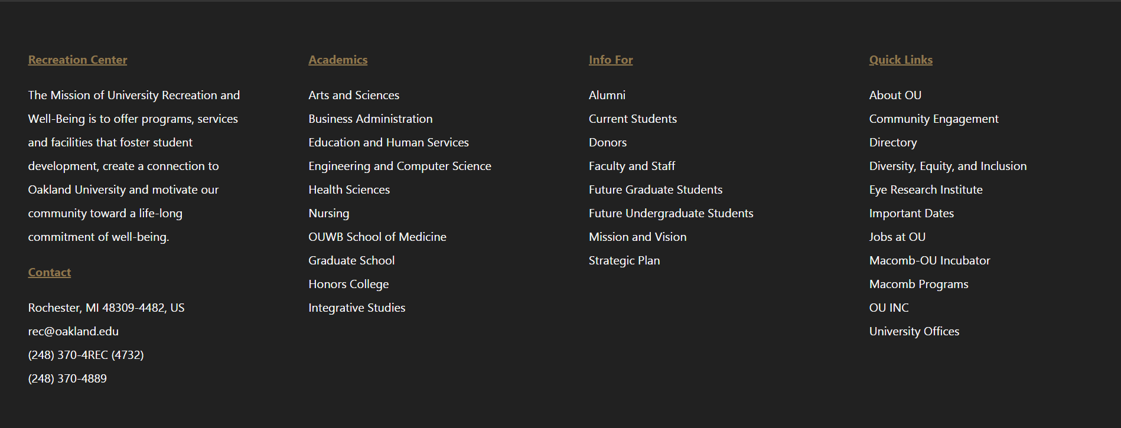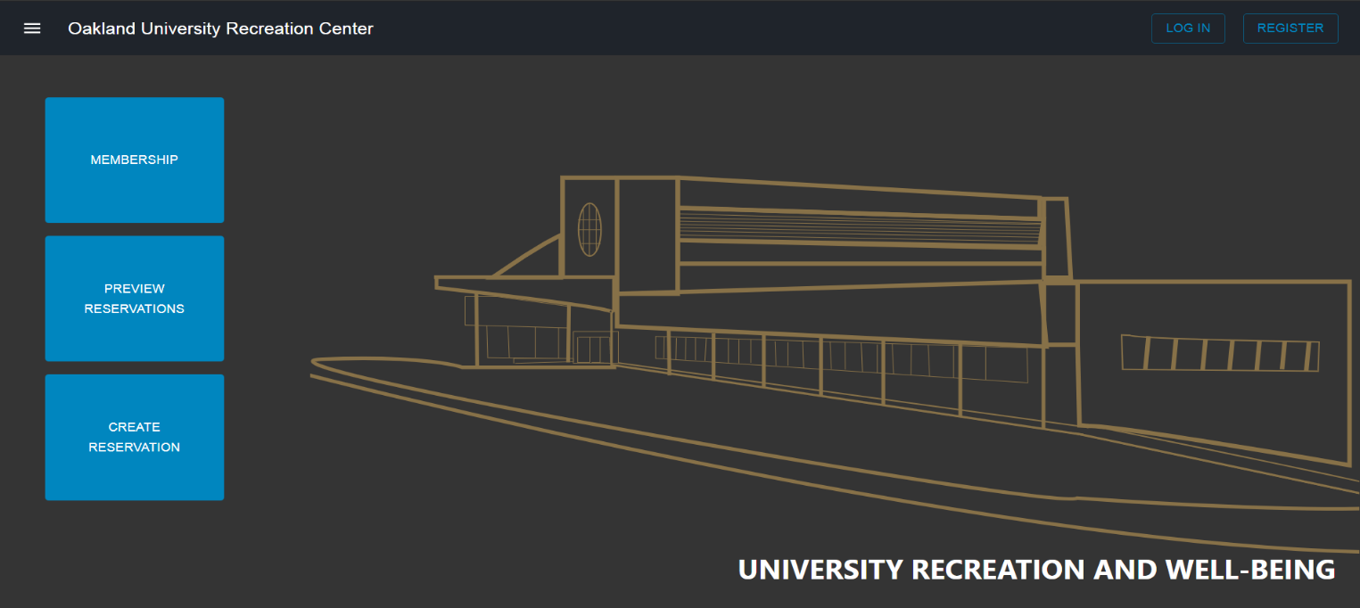 10.1.1 Home Page

The new and improved home page for Oakland University’s Recreation Center. The navigation bar allows users to login/register or use the hamburger menu (explained in 10.1.4) for more information about the Rec Center. The rest of the home page contains membership information, reservations that are currently scheduled at the Rec Center, contact information, and other links to more Oakland University pages.

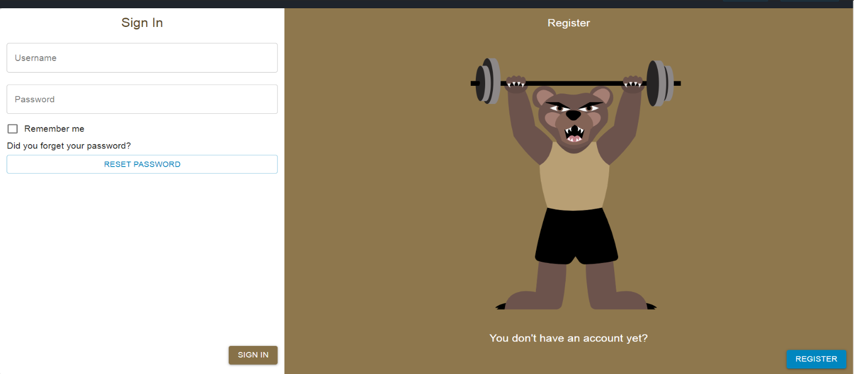 10.1.2 Login

By clicking the login button from the home page, users will be taken here where they can use their provided Oakland University’s email address (ex: johndoe@oakland.edu) to gain access to other features of the web application. They may also navigate to the registration page from here as well if they an account.

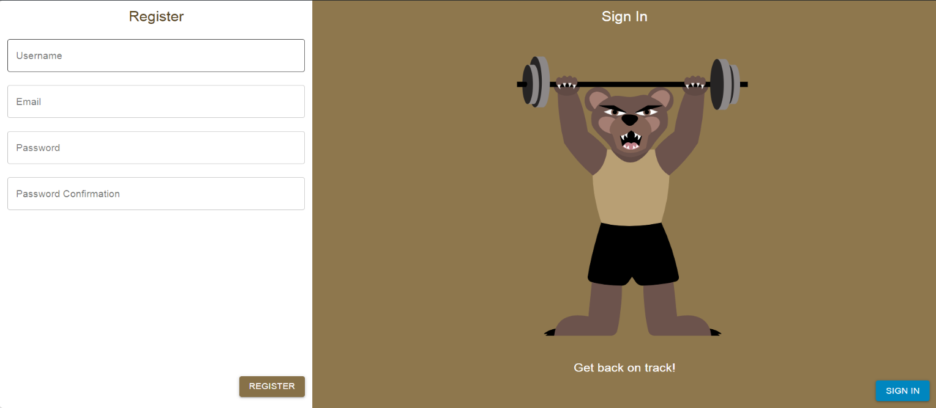10.1.3 Registration

By clicking the register button from the home page or from the login page, users will be taken here where they can create an account, if they don’t have a provided Oakland University email.

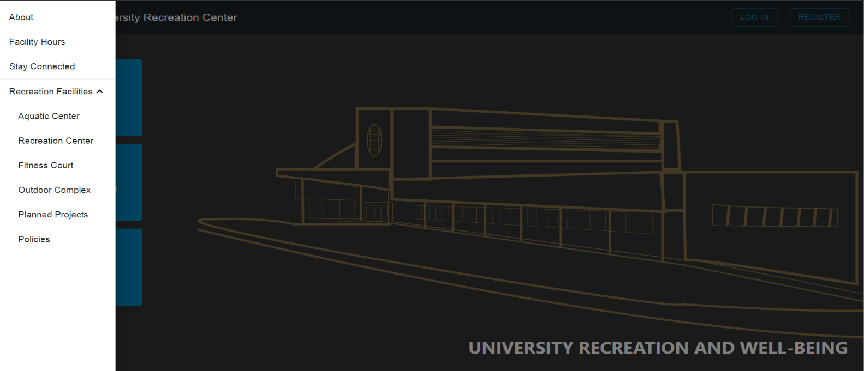10.1.4 Hamburger Menu

From the home page, users can select the hamburger menu (top left corner), to reveal more Recreation Center information. Each tab will go into more detail about each facility, facility hours, employee information, and social media pages.

10.1.5 Calendar

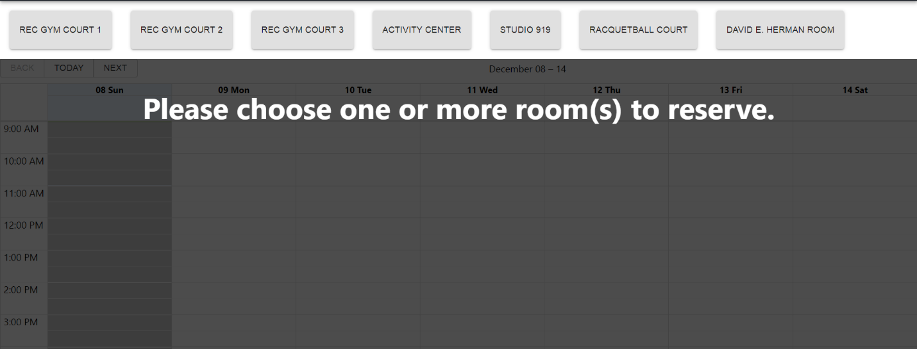This view will vary depending on if you are logged in or not. If you are not logged in, you may be able to view the current reservations at the Rec Center for each facility listed and can filter which ones you are more interested in. If you are logged in, you can still view the current reservations or you can create a reservation by following the on-screen prompts. By selecting a room or more, you will be able to fill out all the information necessary to get your reservation(s) submitted. After filling out all the required information, they user will be redirected to the confirmation screen.

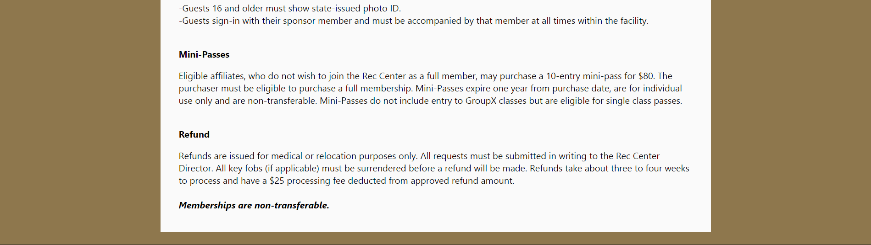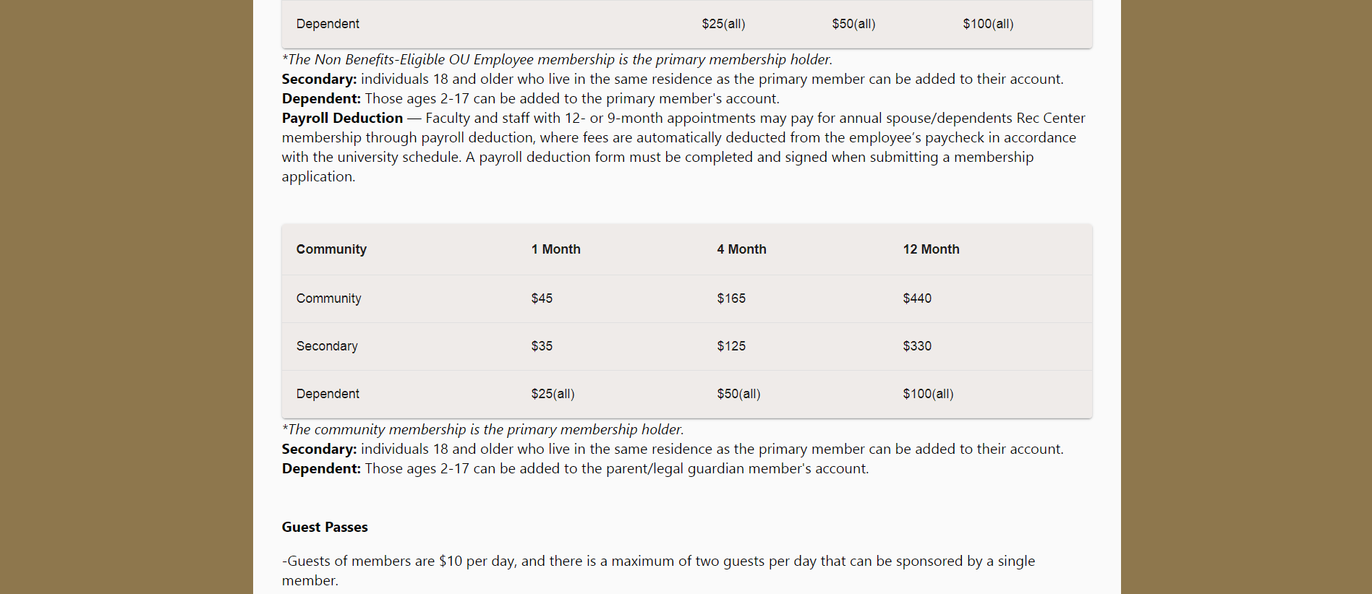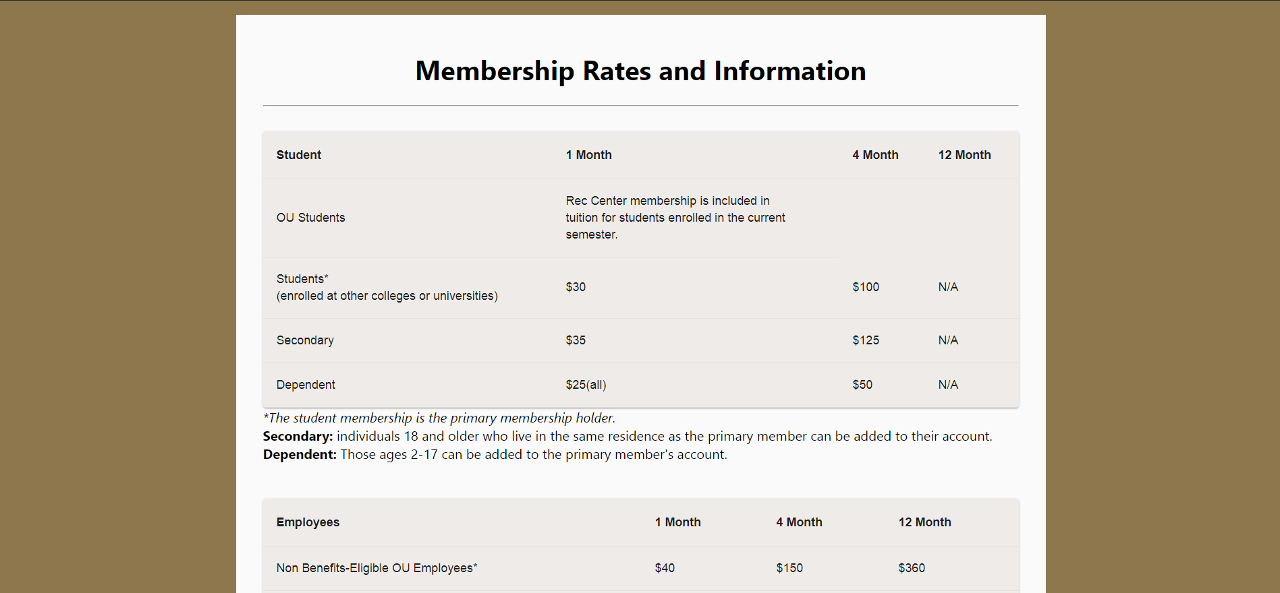10.1.6 Membership Fees

From the home page, you may navigate to the membership fees page, which will give you all the information that you need about membership rates and passes.

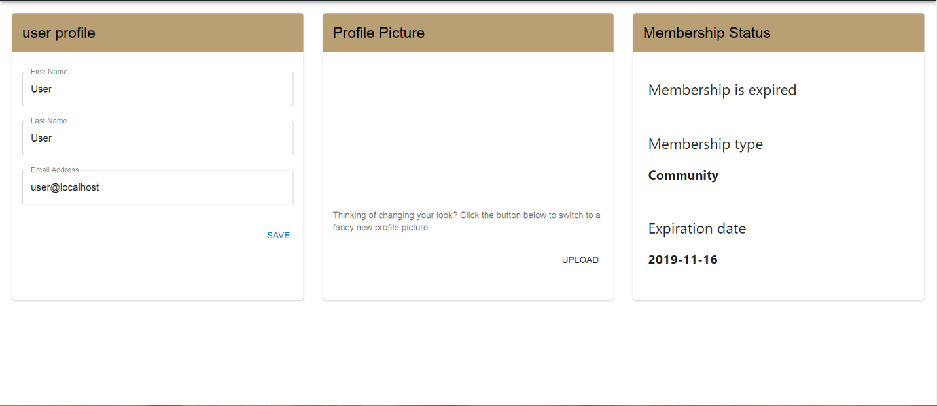10.1.7 Authenticated User Settings

After logging in, the authenticated user may navigate to their ‘Settings’ page by clicking on the user icon in the top right corner. In the user settings page, you can view/update your profile information, upload a profile picture and view membership status.

10.1.8 Authenticated User Reservations

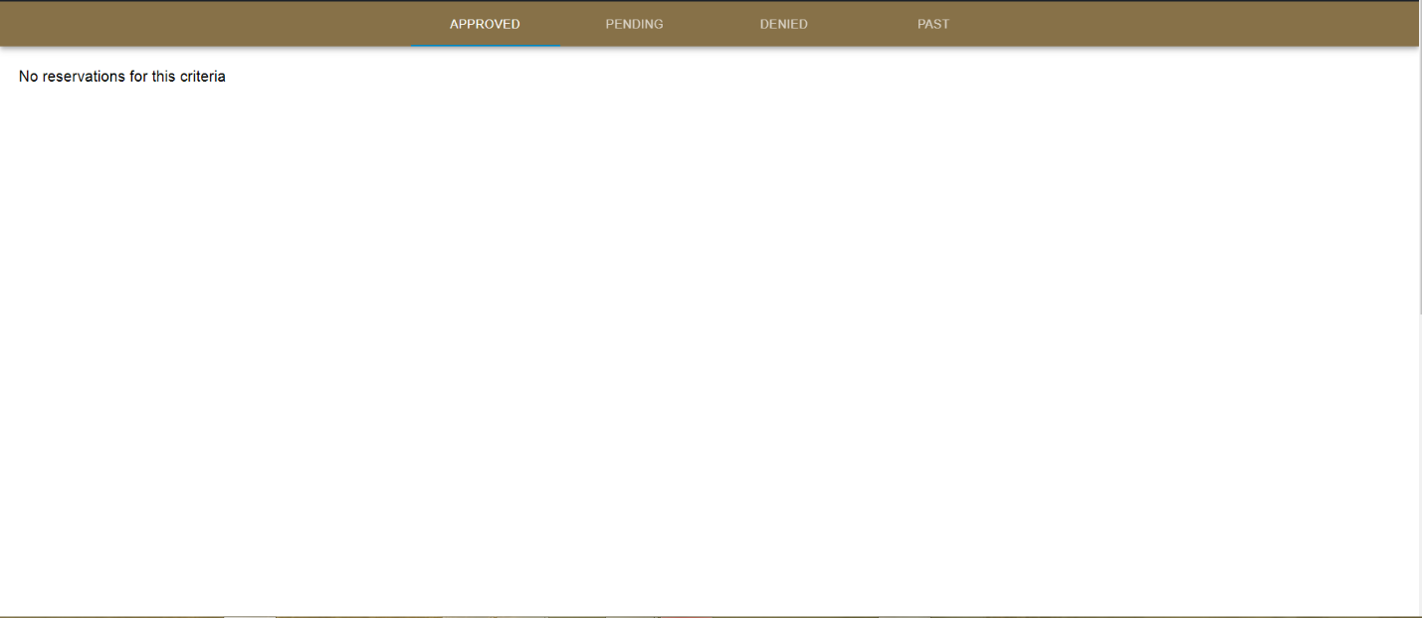After logging in, the authenticated user can also navigate to the ‘My Reservations’ page by clicking on the user icon in the top right corner. Here the user can see the: Pending, Approved, Denied, and Past reservations that he/she made at the Rec Center.

10.1.9 Home Page (Admin View)

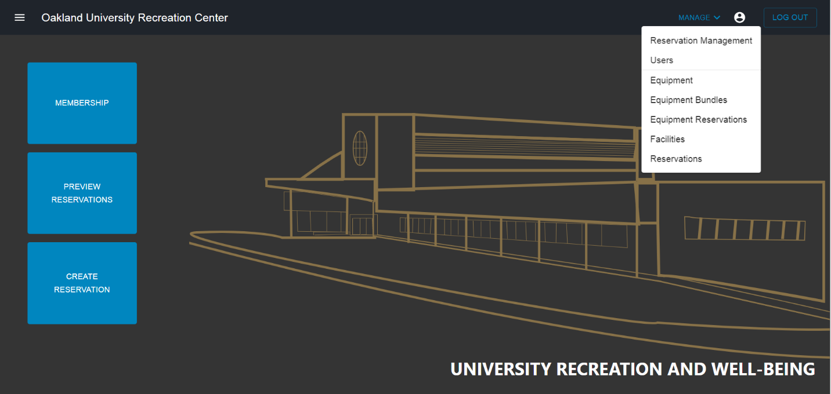When an admin logs in to the OU Rec Center page, they will have an extra ‘Manage’ option to perform various operations for the Rec Center and its facilities.

10.1.10 Reservation Management (Admin ONLY)

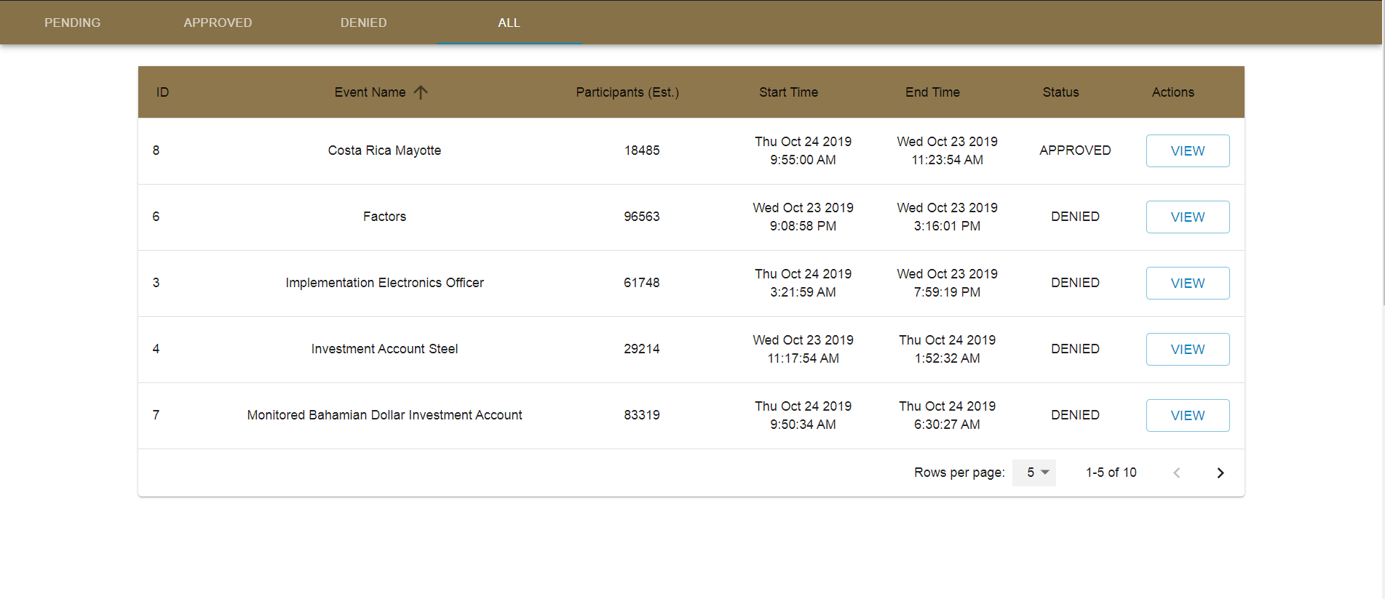While logged in as an admin, they can navigate to the ‘Reservation Management’ page by clicking on the icon in the user icon in the top right corner, where they will be able to view ‘Pending’ reservations made by various users and have the option to ‘Approve’ or ‘Deny’ them based on the criteria and availability for the facility. They will also be able to view ‘Approved’, ‘Denied’, and ‘All’ reservations for the week or month.

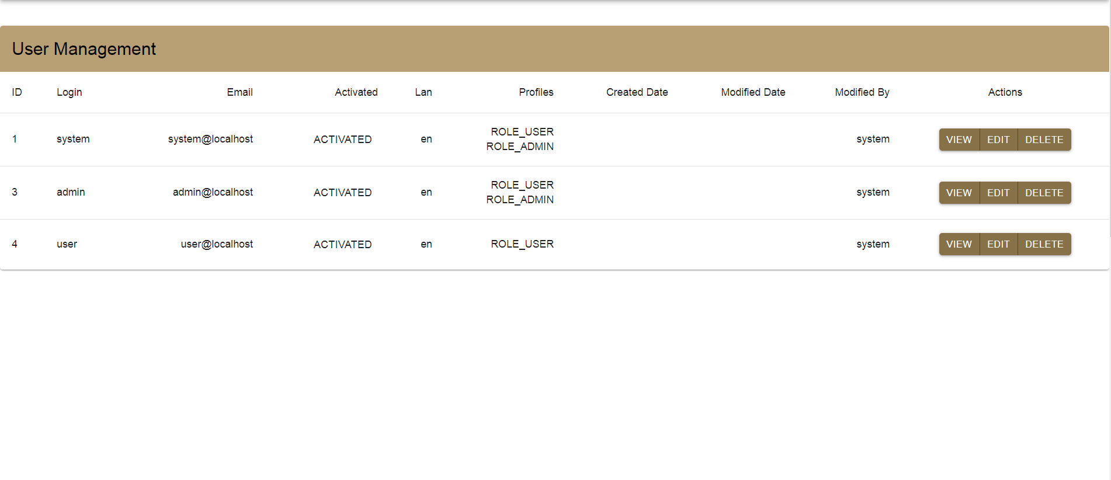10.1.11 User Management (Admin ONLY)

While logged in as an admin, they will be able to navigate to the ‘Users’ page by clicking on the icon in the user icon in the top right corner, where they will have the ability to view, edit, and delete user accounts.

10.1.12 Equipment Entity Management (Admin ONLY)

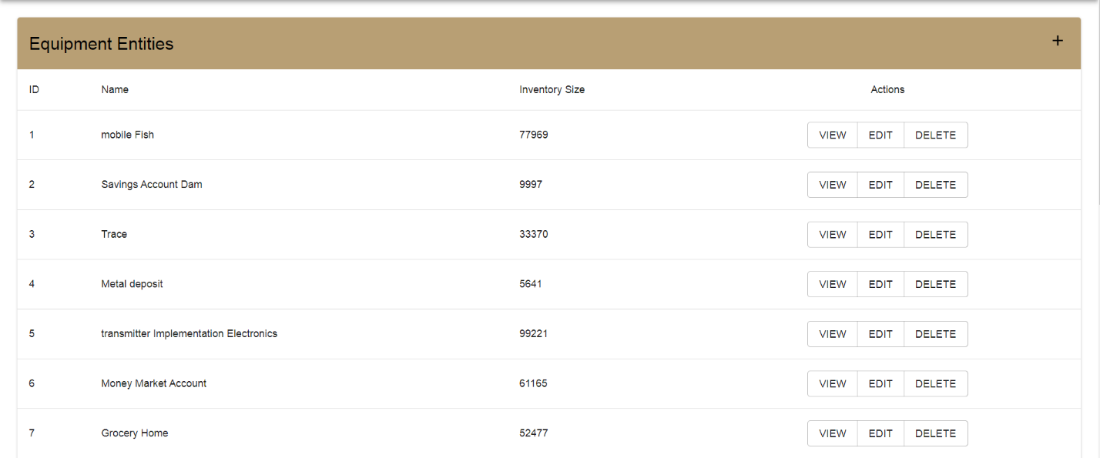

While logged in as an admin, they will be able to navigate to the ‘Equipment’ page by clicking on the icon in the user icon in the top right corner, where they will have the ability to monitor and edit equipment inventory. They will also be able to delete equipment, if necessary.

10.1.13 Equipment Bundles Management (Admin ONLY)

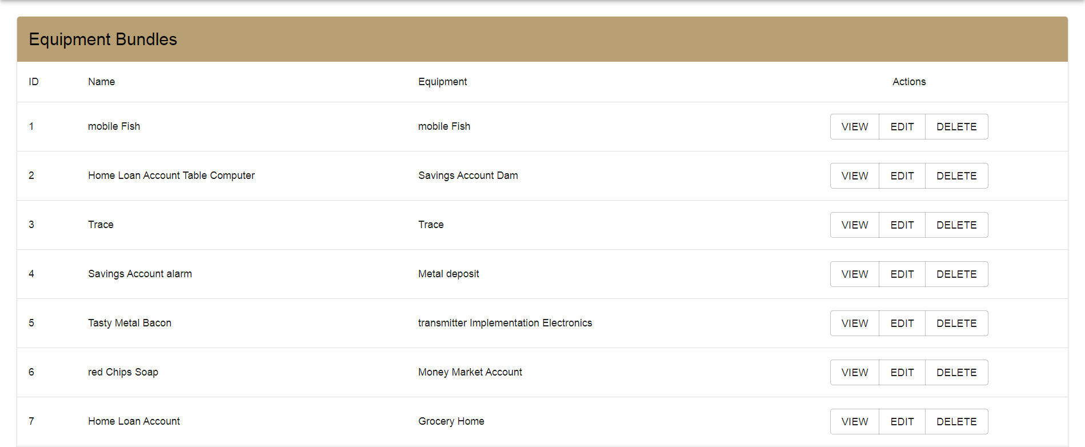

While logged in as an admin, they will be able to navigate to the ‘Equipment Bundles’ page by clicking on the icon in the user icon in the top right corner, where they will be able to view sets of equipment bundles that are pre-set for certain facilities. They will also be able to delete these bundles or add more equipment to bundles, if necessary.

10.1.14 Equipment Reservation Links (Admin ONLY)

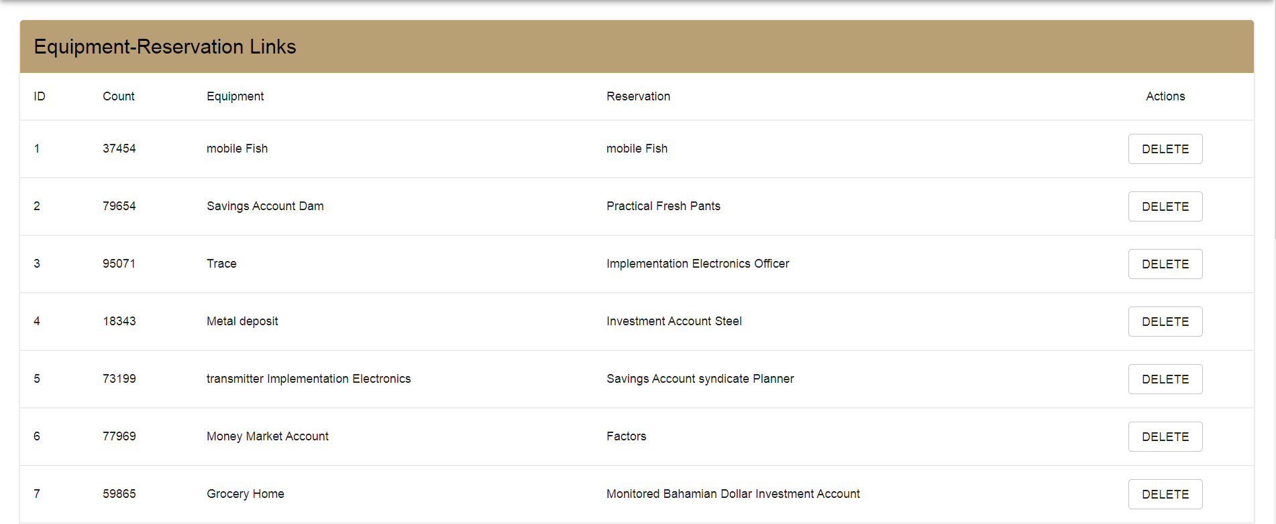

While logged in as an admin, they will be able to navigate to the ‘Equipment Reservations’ page by clicking on the icon in the user icon in the top right corner, where they will be able to view and delete the links for the pre-set bundles for the facilities.

10.1.15 Facilities Management (Admin ONLY)

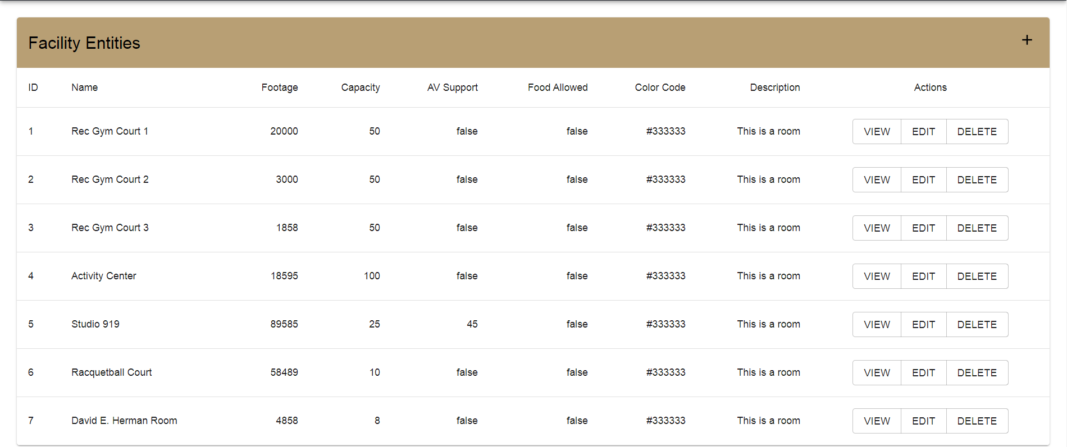

While logged in as an admin, they will be able to navigate to the ‘Equipment Bundles’ page by clicking on the icon in the user icon in the top right corner, where they will be able to view all Rec Center facilities and their information.

10.1.16 Reservations (Admin ONLY)

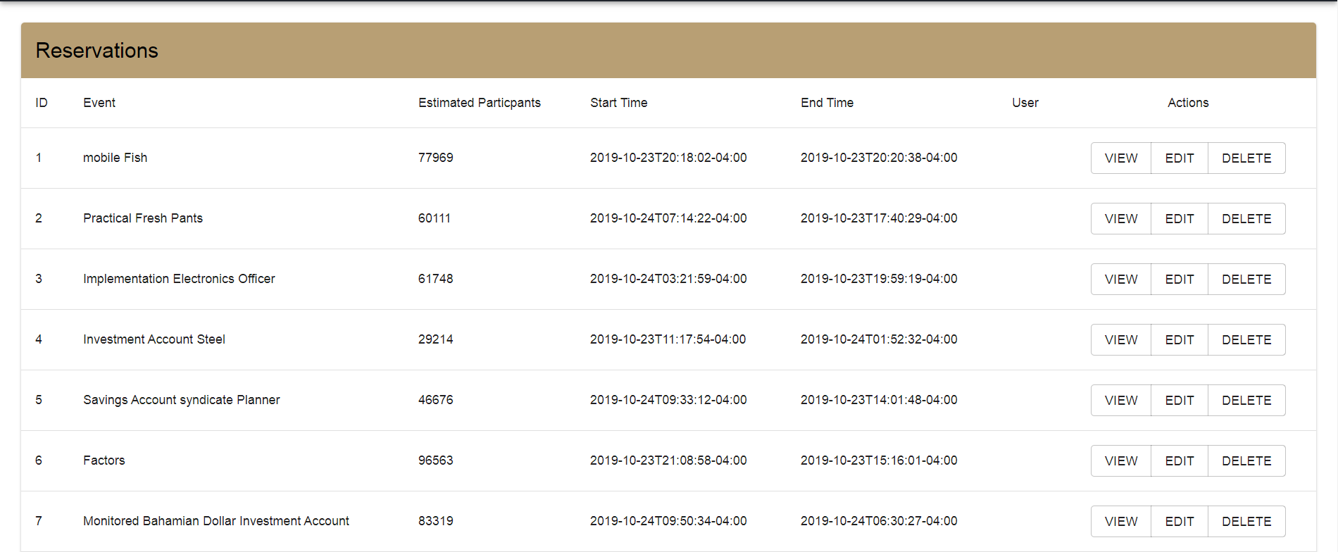

While logged in as an admin, they will be able to navigate to the ‘Reservations’ page by clicking on the icon in the user icon in the top right corner, where they will be able to view all reservations ever made into the Rec Center system. This is different compared to the ‘Reservation Management’ view because this is an unfiltered list, where the ‘Reservation Management’ page is filtered based on the pre-determined limit set to render in.

**10.2 User Interface Implementation**

The user interface for the Oakland University’s Recreation Center was implemented in a way to make its facilities more accessible to the university’s students, faculty, and its surrounding community. The simplistic and sleek redesign is a way for users to quickly navigate the Rec Center’s features and get information. With the redesign, we have added the ability for users to easily create/view reservations for Rec Center facilities, manage their reservations from their user account, and get detailed information on various topics. We also added admin account abilities to be able to manage Rec Center facilities, user accounts, equipment/bundles, and reservations.